8D7N Kunming Shangrila Apr-Jun
Group size: 10-25pax
Period: April- June 2020 (8D7N Kunming-Dali- Lijiang- Shangrila)
Date | City | Schedule |  | Meal
D1 | Kunming- Shilin | Arrival Kunming, Meet our Tour guide and transfer to Check in hotel.  ãLocal 5* Shilin Days Tongce hotel or similar (Vienna royal) | AIR | D
D2 | Shilin- Jiuxiang- Kunming | Visit Shilin (Stone forest include buggy service),  Jiuxiang Karst Cave (inckude cable car+ cruise)  ãLocal 5* Kunming Xin Sheng Da Hong Sheng International hotel or similar  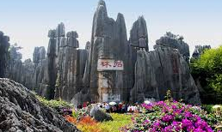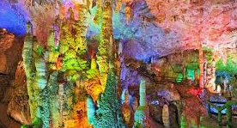 | v | BLD
D3 | Kunming- Dali | By bus to Dali 4.5hours, Visit Dali ancient town (exclude buggy) + Foreigner street  ã4* Dali San Ta Yuan hotel or similar  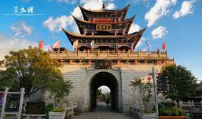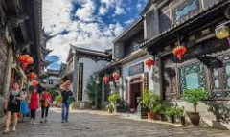 | v | BLD
D4 | Dali- Shangrila | Visit Xizhou White minority village+ Three course tea performance, Chongsheng Three pagodas temple (Outlook). By bus to Shangrila, On the way view First bend of Yangtze river, Visit Tiger leaping gorge, Dukezong ancient old town  ãLocal 5* Shangrila Anxin Blue horizon Junhua hotel or similar  https://www.booking.com/hotel/cn/anxin-blue-horizon-junhua.zh-cn.html  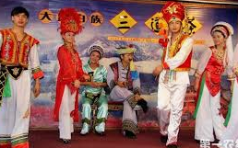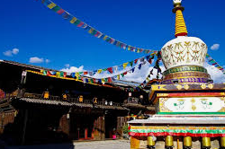 | v | BLD
D5 | Shangrila- Lijiang | Visit Songzanlin temple (include buggy service), Napa lake (exclude horse ride).  By bus to Lijiang, Visit Lijiang ancient city, Square street, Black Dragon lake...  ãLocal 5* Lijiang Xiang Tai hotel or similar  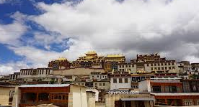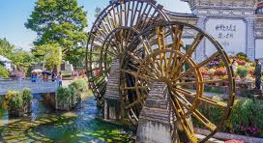 | v | BLD
D6 | Lijiang | Visit Jade Snow Mountain- Yunshanping (include cable car), Dry sea, Jade water village, Impression Lijiang show.  ãLocal 5* Lijiang Xiang Tai hotel or similar  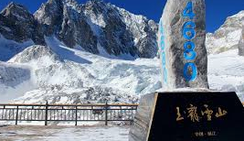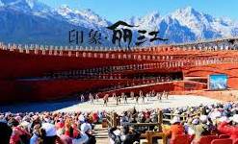 | v | BLD
D7 | Lijiang- Kunming | By bus to Kunming 7-8hours, Visit Golden horse memorial Arch, Nanping street  ãLocal 5* Kunming Xin Sheng Da Hong Sheng International hotel or similar  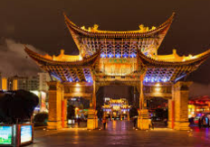 | v | BLD
D8 | Kunming | Visit Xishan dragon gate+ cable car+ buggy+ shuttle bus, transfer out.  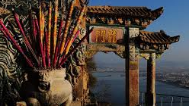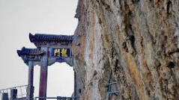 | v | BL

Special meal:
- Noodle over bridge
- Xizhou minority cuisine
- Yunnan’s Specialty

Tour Fare (use 17seater bus) : Usd558 RMB 3800/pax (10+0FOC) Single supplement.: Usd144 RMB980
Tour Fare (use 35seater bus) : Usd603 RMB 4100/pax (10+1FOC)
Tour Fare (use 35seater bus) : Usd507 RMB 3450/pax (15+1FOC)

Tour Fare (use 35seater bus) : Usd467 RMB 3180/pax (20+1FOC)
Tour Fare (use 47seater bus) : Usd463 RMB 3150/pax (25+1FOC)
Tour Fare (use 47seater bus) : Usd456 RMB 3100/pax (30+2FOC)

Remarks:
1) Include meal, Mandarin/English guide (every city one local guide), Entrance ticket, hotel (twin sharing)
2) Exclude Tips- Usd 3/pax/day， Optional tour, air ticket, bell boy
3) Compulsory Shopping: NO
4) Meal budget: RMB 40/pax/meal
5) Child with bed: 100% Child no bed: 75% (Child no bed exclude hotel breakfast)
6) FOC based on twin sharing
7) Free one mineral water per pax per day 350ml
8) Optional tour: Yunnan impression performance show RMB300/pax (Tour leader commision RMB 20/pax)
9) Tour leader please bring tour leader lisence, otherwise entrance ticket pay by own.

